**Project Title – “Government Schemes Management System”**

**Phase 3: Data Modeling & Relationships**

**Standard & Custom Objects**

* Account (Standard): Represents government offices, agencies, or organizations managing schemes.
* Contact (Standard): Stores citizens or scheme applicants.
* Scheme__c (Custom): Tracks government schemes (type, start/end dates, eligibility, budget).
* Scheme_Application__c (Custom): Stores applications submitted by citizens for schemes.
* Fund_Transaction__c (Custom): Tracks fund disbursements and receipts related to schemes.
* Grievance__c (Custom): Records complaints or feedback from citizens regarding schemes or fund transactions.

Data Flow: Account → Contact → Scheme__c -> Scheme_Application__c → Fund_Transaction__c → Grievance__c

**Master-Detail & Lookup Relationships**

1. Scheme_Application__c → Scheme__c
   * Relationship Type: Lookup
   * Purpose: Each application belongs to a particular scheme.
2. Fund_Transaction__c → Scheme_Application__c
   * Relationship Type: Lookup
   * Purpose: Tracks payments/disbursements related to a specific application.
3. Grievance__c → Scheme_Application__c
   * Relationship Type: Lookup
   * Purpose: Links complaints to the corresponding citizen application.
4. Contact → Account
   * Relationship Type: Lookup (or optionally Master-Detail for stricter access)
   * Purpose: Each citizen belongs to a particular account/agency (for internal management).

**Fields for Custom Objects**

**Scheme__c**

* Scheme Code (Text, 50, unique, required)
* Scheme Name (Text, 80, required)
* Description (Long Text Area)
* Start Date (Date)
* End Date (Date)
* Active (Checkbox)
* Max Amount (Currency)
* Eligibility Criteria (Long Text Area)

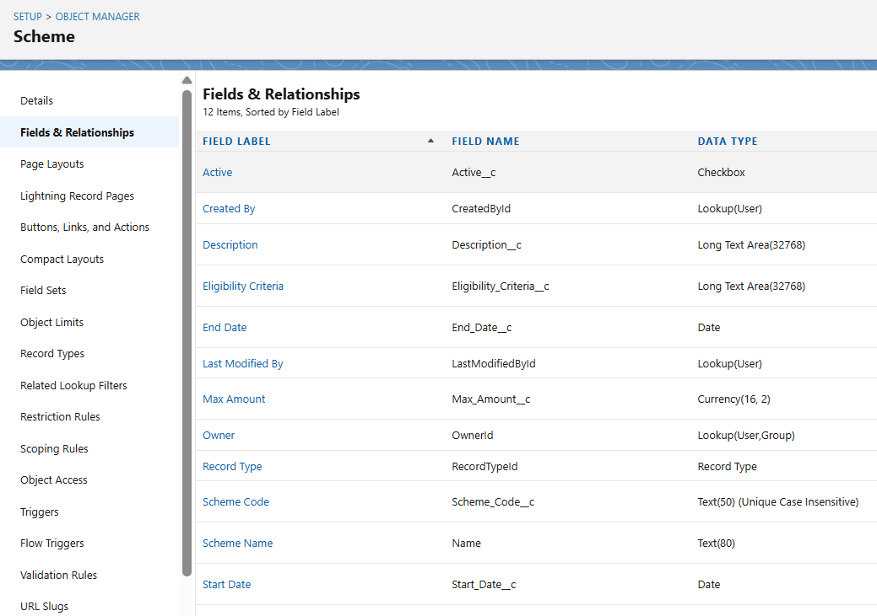

**Scheme_Application__c**

* Application Name (Auto Number)
* Requested Amount (Currency)
* Approved Amount (Currency)
* Contact (Lookup → Contact)
* Scheme (Lookup → Scheme__c)
* Status (Picklist: Submitted, Approved, Rejected, Pending)
* Submission Date (Date)

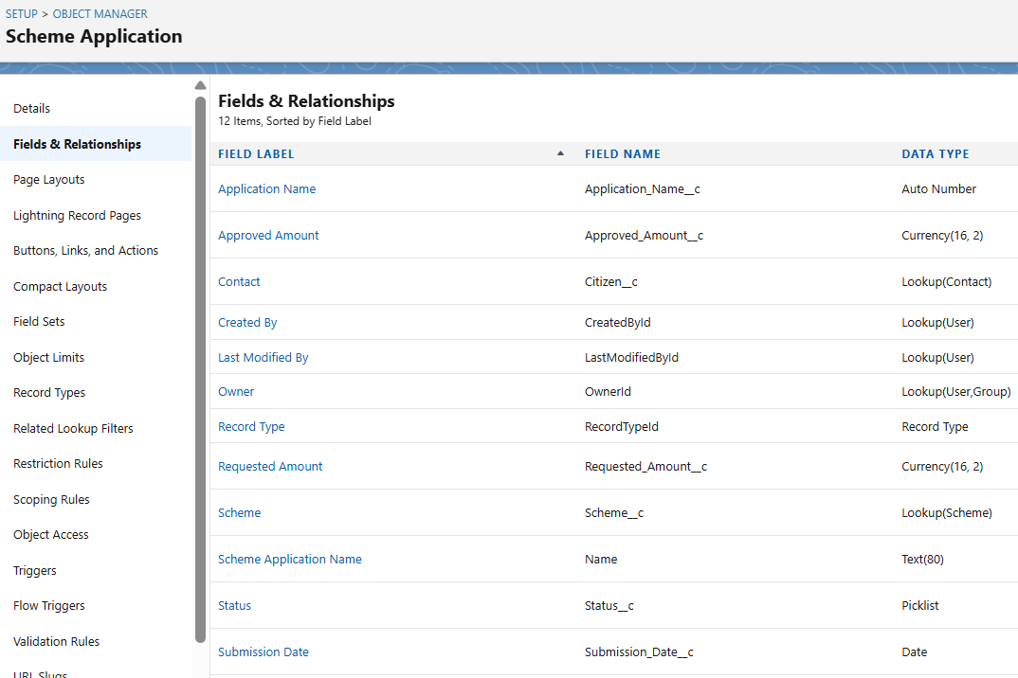

**Fund_Transaction__c**

* Fund Transaction Name (Auto Number)
* Scheme Application (Lookup → Scheme_Application__c)
* Amount (Currency)
* Payment Date (Date)
* Payment Status (Picklist: Pending, Paid, Failed)

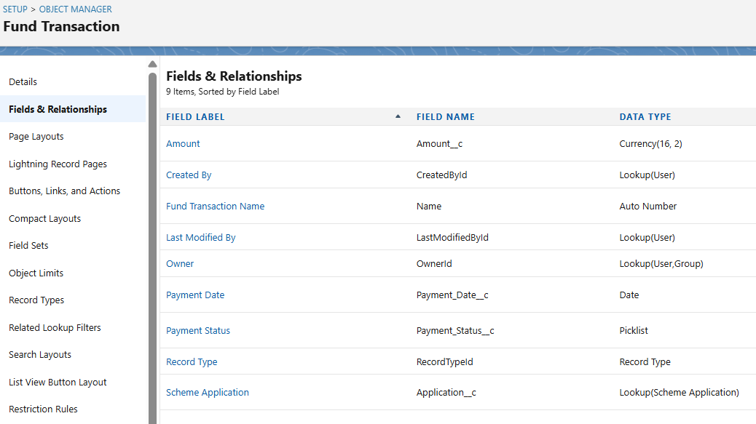

**Grievance__c**

* Grievance Name (Auto Number)
* Contact (Lookup → Contact)
* Scheme Application (Lookup → Scheme_Application__c)
* Category (Picklist: Scheme Complaint, Payment Complaint, General Feedback)
* Status (Picklist: Open, In Progress, Resolved)
* Resolution Notes (Long Text Area)

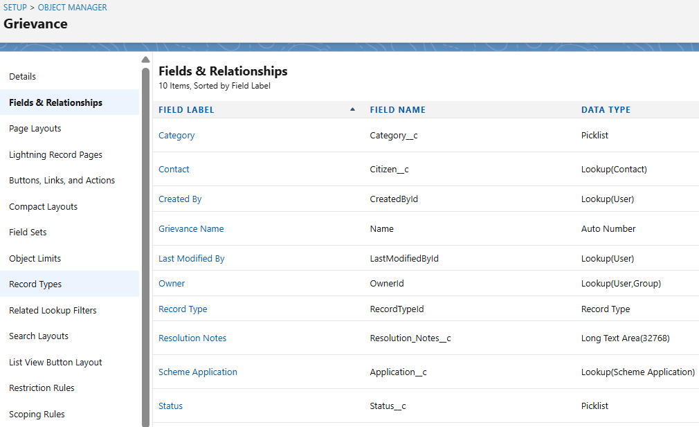

**Page Layouts**

**Scheme__c Layout**

* Sections: Header (Scheme Code, Scheme Name), Details (Start/End Date, Description, Eligibility Criteria, Max Amount, Active)
* Related Lists: Applications, Fund Transactions, Grievances

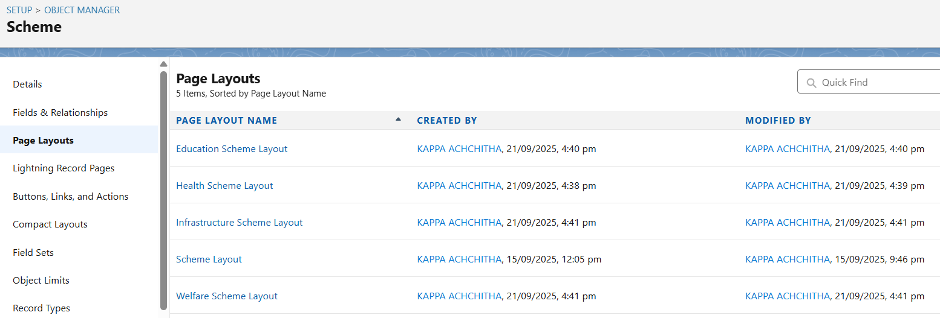

**Scheme_Application__c Layout**

* Sections: Header (Application Name, Contact), Application Details (Requested/Approved Amount, Status, Submission Date)
* Related Lists: Fund Transactions, Grievances

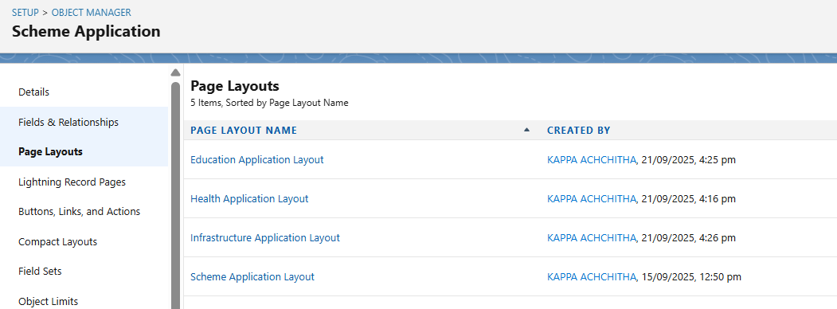

**Fund_Transaction__c Layout**

* Fields: Fund Transaction Name, Scheme Application, Amount, Payment Date, Payment Status

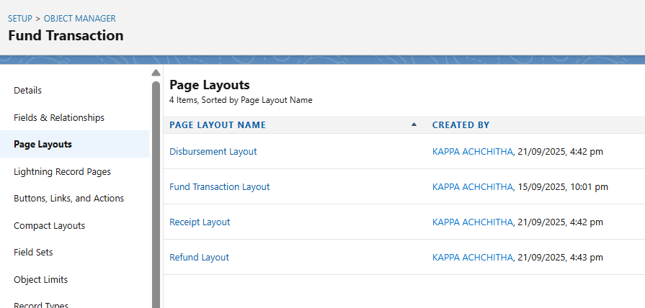

**Grievance__c Layout**

* Fields: Grievance Name, Contact, Scheme Application, Category, Status, Resolution Notes

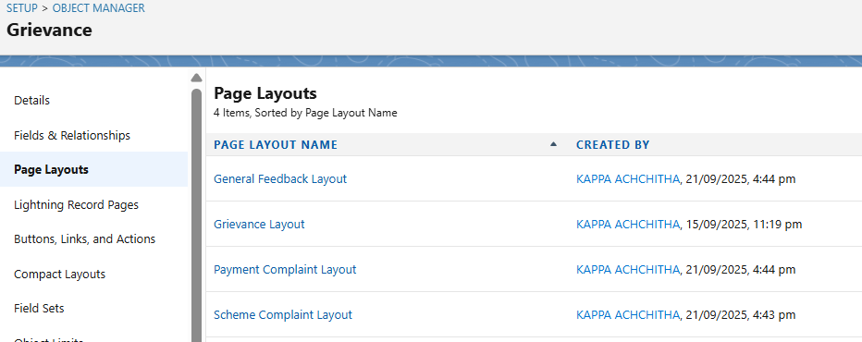

**Compact Layouts**

**Scheme__c**

* Display Fields: Scheme Code, Scheme Name, Active

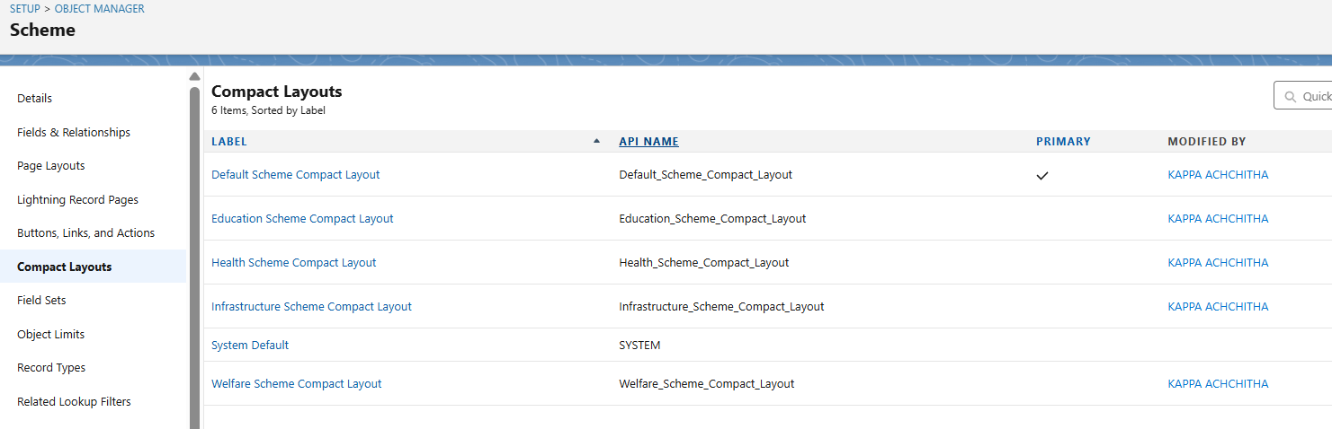

**Scheme_Application__c**

* Display Fields: Application Name, Status, Requested Amount

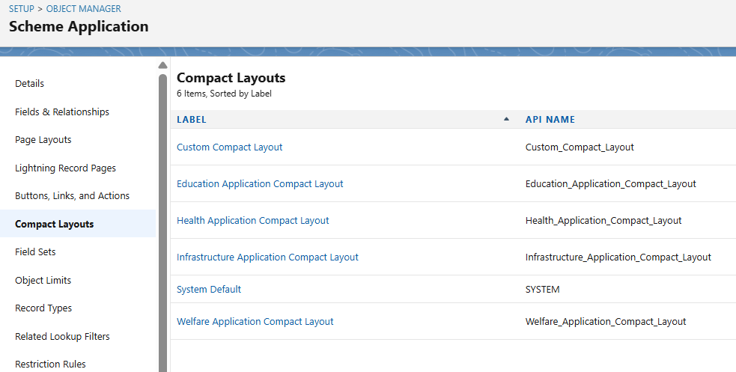

**Fund_Transaction__c**

* Display Fields: Fund Transaction Name, Amount, Payment Status

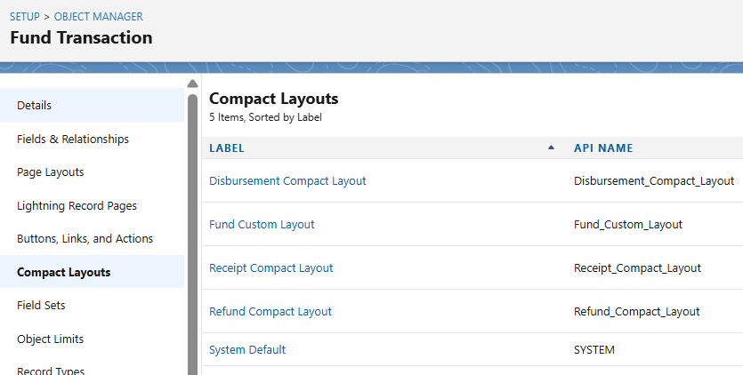

**Grievance__c**

* Display Fields: Grievance Name, Category, Status

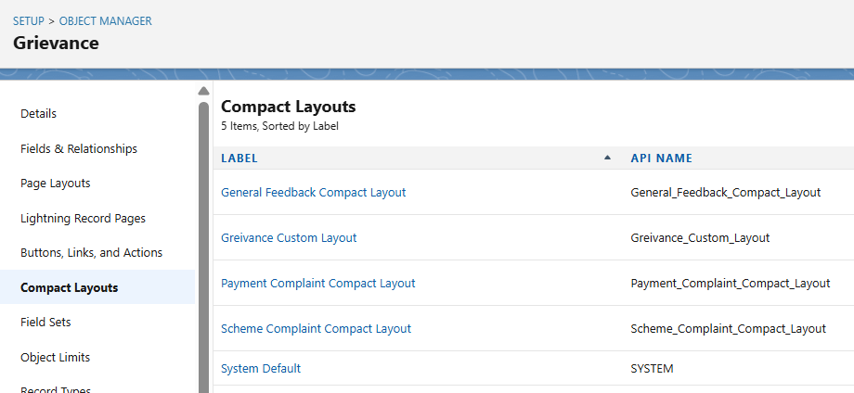

**Record Types**

**Scheme__c**

* Health Scheme, Education Scheme, Welfare Scheme, Infrastructure Scheme

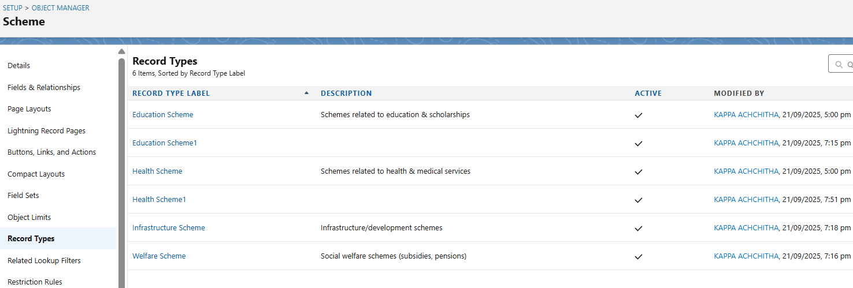

**Scheme_Application__c**

* Health Application, Education Application, Welfare Application, Infrastructure Application

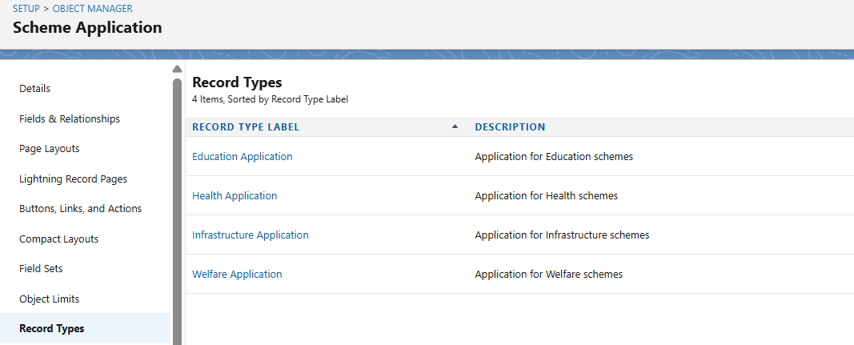

**Fund_Transaction__c**

* Disbursement, Receipt, Refund

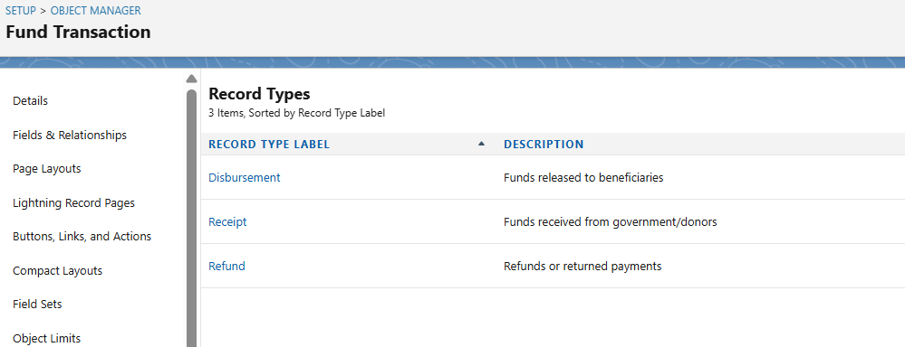

**Grievance__c**

* Scheme Complaint, Payment/Transaction Complaint, General Feedback

Note: Different record types allow for different page layouts, picklist values, and visibility for officers, auditors, and citizens.

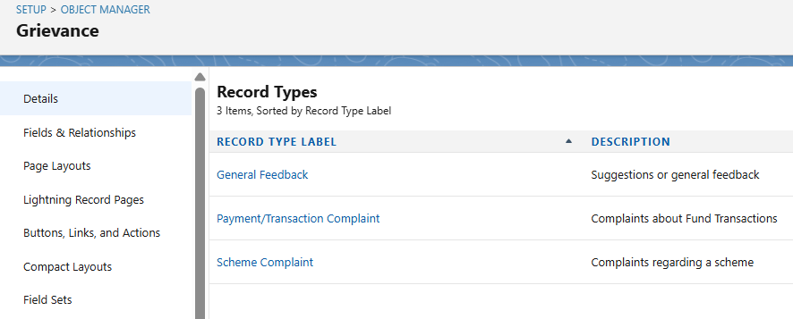

**Schema Builder**

* Used to visually confirm relationships: Lookup and Master-Detail between objects.
* Steps:
  1. Setup → Object Manager → Schema Builder
  2. Select Objects: Scheme, Scheme Application, Fund Transaction, Grievance, Contact, Account
  3. Arrange objects to visualize data flow and relationships
  4. Verify that Master-Detail and Lookup relationships are correctly displayed

**Lookup vs Master-Detail vs Hierarchical Relationships**

* Lookup: Optional relationship; used for linking Scheme Application → Scheme, Grievance → Scheme Application.
* Master-Detail: Enforces ownership inheritance; can be used if Scheme Application must strictly belong to Scheme.
* Hierarchical: Only available for User object; not used in this project.

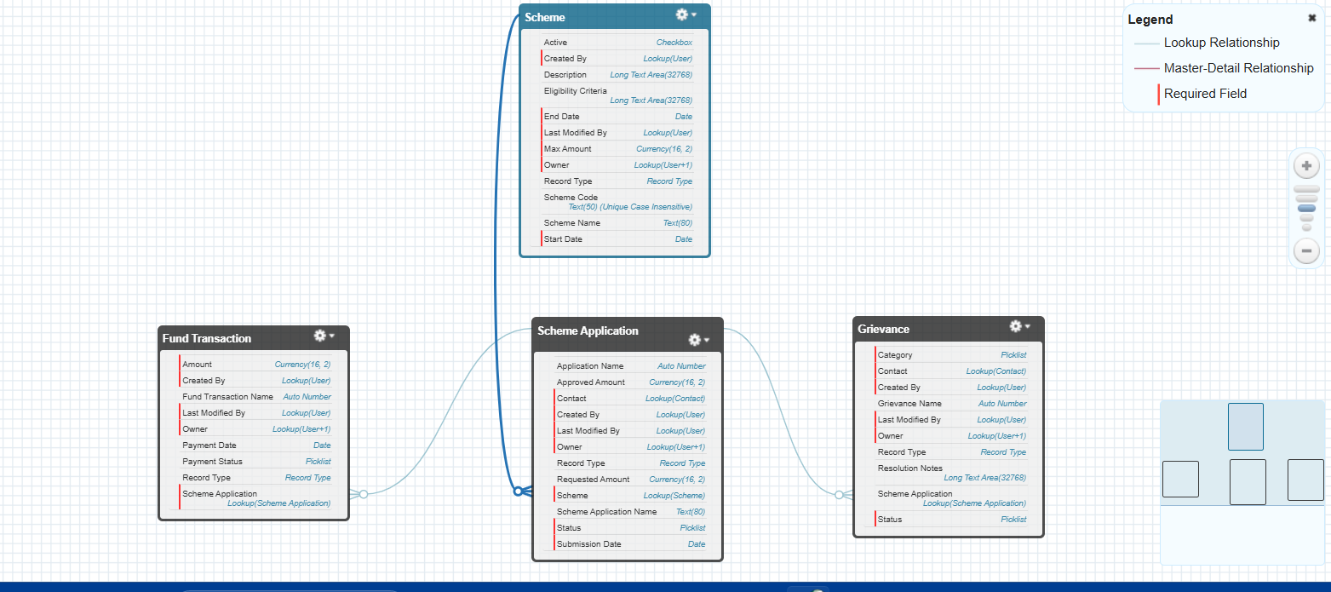

**Junction Objects**

* Not used; no many-to-many relationships needed. Each application, transaction, or grievance links to a single scheme/application.

**External Objects**

* Not used; no external data sources are integrated. All data is stored within Salesforce standard/custom objects.